**1.Iterator Pattern**

Download “1.IteratorPattern” project and import it into your IDE(i.e. Eclipse).

Go into “src” folder.

### Iterator Pattern – src/example ###

# What does Iterator Pattern do?

-Iterator Pattern allows you to cycle through list of classes.

# Why use Iterator Pattern and not just for loop?

-If you want to do specific things to specific objects as you iterate, for loop has a lot of restrictions. You can make simpler codes with iterator.

-You can use iterator in any “iterable” object. Universal and Reusable.

-You can create multiple iterators that runs separately.

# How does simplest form of an Iterator Pattern look like?

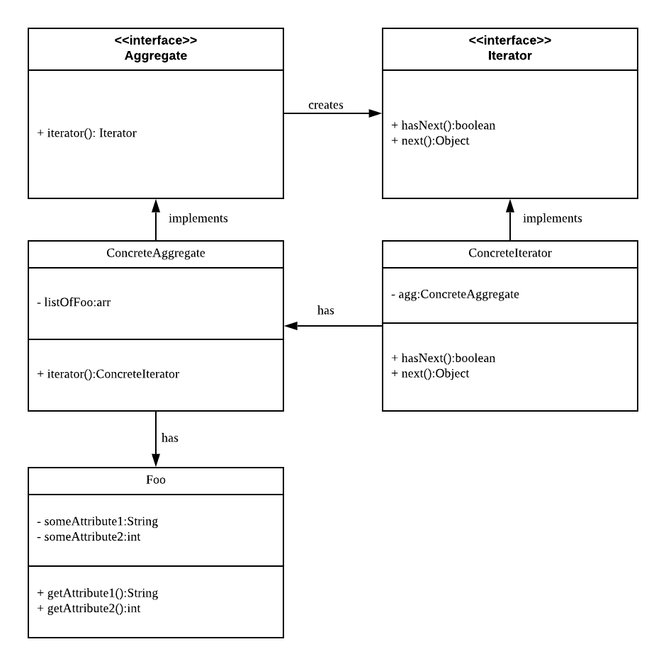

-Mandatory Interface: Aggregate, Iterator

-There has to be a group(Aggregate) of some object(foo) to iterate.

# Our Example

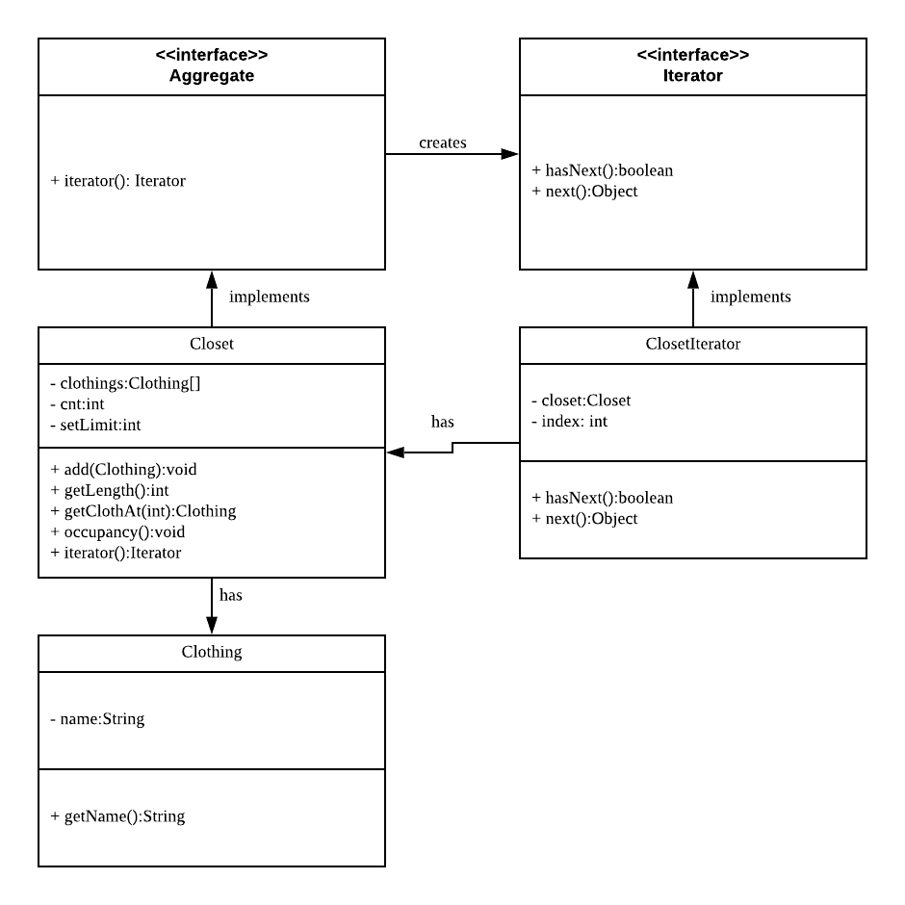

### Problem ###

### Further Ahead! ###

# ListIterator Interface

-ListIterator is an iterator pattern with more functions: hasPrevious(), previous(), remove(), etc.

-Iterator can only go forward, but ListIterator can also go backward.

#